ATHLETES-

To whom it may concern;

You are receiving this letter because I do not have one of the following:

* a baseline concussion test
* your baseline concussion test is expiring
* or your baseline concussion test was too low and you need to retake it.

This is a computerized baseline concussion testing that is required prior to participating in athletics. This is a tool to assess your current cognitive levels. This test takes approximately 10-15 minutes to complete. This test is ***good for 2 years***- you do not need to take it every season or every year.

Test dates, times, location- Use QR code to access Google Form or use link <https://docs.google.com/forms/d/e/1FAIpQLSc7biwTZ01ZloLkmyg479pO0rF_f0WLQeRMtcNZkklwQVwntQ/viewform?usp=header>

Monday February 24

Lunch 12:00 - room 916

After school 3:00, 3:15, 3:30, 3:45 - room 916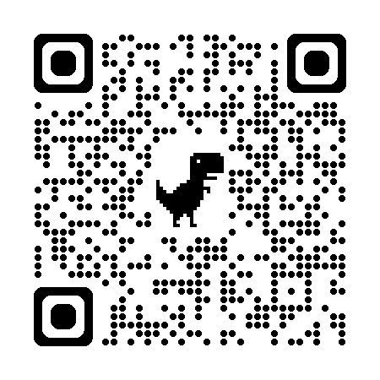

Tuesday February 25

Lunch 12:00- room 916

Wednesday February 26

After school 3:00, 3:15, 3:30,3:45 - room 916

Thursday February 27

Lunch 12:00 - room 916

After school 3:00, 3:15, 3:30, 3:45 - room 916

Friday February 28

Lunch 12:00 - room 916

After school 3:00, 3:15, 3:30, 3:45 - room 916

Please contact me if this time will not work and I will try to accommodate

Miss Shaunna Olson, Certified Athletic Trainer

Sports Medicine teacher

[solson@portangelesschools.org](mailto:solson@portangelesschools.org)

Remind App

<http://www.remind.com/join/ShaunnaOl>